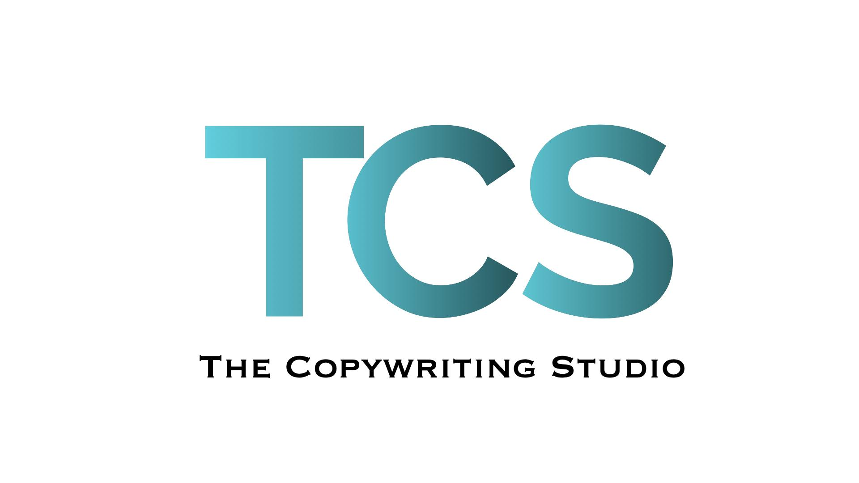

Filling out forms can be a pain. So if you prefer, I can fill this out with you over the phone.

But I do need a brief. It helps me understand your business, customers and copy needs, and stops me bothering you with loads of questions whilst I write. Plus, I’m nosy.

**CLIENT NAME:**

|  |
| --- |
|  |

**COMPANY:**

|  |
| --- |
|  |

**CONTACT DETAILS:**

|  |
| --- |
| Email:  Telephone:  Address: |

**TODAY’S DATE:**

|  |
| --- |
|  |

**FIRST DRAFT DEADLINE:**

|  |
| --- |
|  |

**FINAL COPY DEADLINE:**

|  |
| --- |
|  |

**Describe what your company does.**

*For example: “we are custom furniture makers and we’ve been creating bespoke fitted furniture from sustainable wood since 2008.”*

|  |
| --- |
|  |

**How does your product or service make your customers’ lives better?**

*For example: “from kitchens to loft storage - every piece we make is handmade to order with the finest sustainable materials. So our customers get stunning furniture that will last a lifetime.”*

|  |
| --- |
|  |

**What do you want to achieve with the copy?**

*For example: Attract new customers. Communicate better with current customers. Change the brand tone of voice. Position your product / services differently. Improve SEO.*

|  |
| --- |
|  |

**Who are your competitors?**

*Provide website links. Who are they? Tell me their positives. What does their marketing look like?*

|  |
| --- |
|  |

**What makes you unique or different from them?**

*For example: “we are a father and son team with 50 years furniture crafting experience. We fit every piece ourselves and won’t compromise on quality. Our attention to detail ensures everything we produce is beautiful inside and out.”*

|  |
| --- |
|  |

**What copy do you need?** (Deliverables)

|  |
| --- |
|  |

**Who are we talking to?** (Your target audience)

*Who are they? What are they like?*

|  |
| --- |
|  |

**How are you saying it?** *(Tone of voice)*

*Examples: Edgy. Informative. Trustworthy. Quirky. Scientific. Smart. Funny. Authoritative. Enthusiastic.*

|  |
| --- |
|  |

**What do you want them to do?** *(Call to action, key messaging)*

*Please include as much detail about what you’d like included in the copy.*

*Word count requirements. Formatting info (bullet points etc). URLs of existing content to reference or rewrite. Specific keywords you’d like or want to avoid.*

|  |
| --- |
|  |

**What other brands’ copy or marketing material do you like?**

*You can list more than one. It doesn’t have to be in your sector*

|  |
| --- |
|  |

**Any web copy or marketing material you hate?**

*It can be your own previous work, or someone else's. It’s good to know what to avoid!*

|  |
| --- |
|  |

**Are there any other materials I may need to do this work?**

*Images, current marketing material, wireframe template, sitemap of your website etc…*

*Please attach when you send this brief.*

|  |
| --- |
|  |

Phew. All done! Thank you for filling this out.

Please return it to: [jo@thecopywritingstudio.co.uk](mailto:jo@thecopywritingstudio.co.uk)

And remember to include any other information and attachments.